+headT



DEFENCE FORCES TECHNICAL COLLEGE

DIPLOMA IN ELECTRICAL AND ELECTRONICS ENGINEERING

POWER OPTION

**TRADE PROJECT**

**PROJECT TITLE:** DESIGN AND FABRICATION OF DORMITOR FIRE COUNTERING AND RESCUE SYSTEM

**UNIT CODE:** DEE 3148

**PRESENTED BY:** 137 865 SPTE K.N SIMEL

**ADM NO:** DE/209/0008/2022

**PRESENTED TO:** DEPARTMENT OF ELECTRICAL AND ELECTRONICS ENGINEERING (POWER OPTION)

**SUPERVISOR:** MR. ASIMETO

# 

TE

DECLARATION

This proposal is my original work and has never been presented for the award of diploma in any other institution.

STUDENTS NAME: ONYANGO DUNCUN

SIGNATURE…………………………. Date………………………………

SUPERVISORS NAME: CAPT MAENDELEO

# DECLARATION

This proposal is my original work and has not been presented for the diploma award in any other institution.

STUDENT NAME: KELVIN SIMEL

SIGNATURE…………………………. Date………………………………

This trade project has been submitted for examination with the approval of my supervisor

SUPERVISORS NAME: MR ASIMETO

SIGNATURE…………………………. Date……………………………….

# DEDICATION

I dedicate this project to my parents, Kelvin Simel and the entire family, for the support and encouragement they gave me during the entire project writing process. I also dedicate it to the entire National Defence University for making it a success. May God bless you.

# ACKNOWLEDGEMENT

First and foremost, I would like to thank the Almighty God for the gift of life. I would also like to convey my special thanks to my supervisor Mr. Asimeto andthe rest of my coursemates for their selfless support throughout the project writing period.

**TABLE OF CONTENTS**

DECLARATION 1

DEDICATION 2

ACKNOWLEDGEMENT 3

ABSTRACT 6

CHAPTER ONE: INTRODUCTION 7

**1.0 Introduction** 7

**1.1 Background Information** 7

**1.2 Problem Statement** 8

**1.3 Objectives** 8

Main Objective 8

Specific Objectives 8

**1.4 Hypothesis / Research Questions** 9

Hypothesis 9

Research Questions 9

**1.5 Significance of the Study** 9

**1.6 Conceptual and Theoretical Framework** 10

1.6.1 Conceptual Framework 10

1.6.2 Theoretical Framework 11

**1.7 Scope of Study 12**

CHAPTER TWO: LITERATURE REVIEW 14

**2.2 Critique of Existing Design** 14

**2.3 Evaluation of Proposal Design 15**

2.3.1 Power supply 15

2.3.2 Smoke Sensor 18

2.3.3 Heat Sensor 19

2.3.4 Audio alarm 20

2.3.5 Control Unit 21

2.3.6 GSM Module 26

2.3.7Motor 27

**2.4 Summary of the Gaps Identified 28**

CHAPTER THREE: PROJECT DESIGN 30

**3.1 Power supply** 30

3.1.1Transformer 30

3.1.2 Rectification 31

3.1.3 Smoothing 32

3.1.4 Voltage Regulator 32

3.1.5 Voltage comparator 33

3.2 Smoke sensing Circuit 34

3.3 Flame Sensor 35

3.4 Alarm Driver 36

3.5 **Audio alarm** 37

3.6 Control Circuit 38

3.7 GSM Module 39

3.8 **Switching circuit** 39

3.9 **DOOR MOTOR** 41

3.12 **CIRCUIT DIAGRAM** 42

3.13 **CIRCUIT OPERATION** 42

# ABSTRACT

The design and fabrication of a Dormitory Fire Counter and Rescue System in Kenya aims to address the increasing concerns over fire safety in dormitories, especially in educational institutions. Fires in dormitories pose significant risks to students' lives and property, exacerbated by inadequate fire prevention measures and inefficient emergency response systems. This project proposes a comprehensive solution that integrates fire prevention and real-time rescue mechanisms, including automated fire detection, alarms, sprinkler systems, and an efficient evacuation protocol. The system will utilize locally available materials and technologies suitable for the Kenyan context, ensuring affordability and ease of maintenance. Additionally, the system will feature an emergency communication network to guide students and staff during an evacuation. Through this design, the project seeks to enhance overall safety, minimize fire-related injuries, and promote quicker, organized evacuations in the event of a fire emergency in dormitory settings across Kenya.

# CHAPTER ONE: INTRODUCTION

## **1.0 Introduction**

Fire safety in residential buildings, particularly school dormitories, is a critical concern due to the dense occupancy of students and the risks posed by fire-related incidents. A dormitory serves as a residential facility where students live while pursuing their education, offering convenience and fostering community engagement. However, the communal living environment of dormitories creates specific challenges in ensuring the safety and security of its occupants, especially in the event of a fire.

Fires in dormitories are dangerous due to the high population density, limited escape routes, and the presence of young individuals who may not be well-versed in fire safety practices. These factors contribute to heightened risks of injuries, fatalities, and property damage. Despite the presence of traditional firefighting measures, most existing systems rely heavily on manual intervention, which may delay the detection and response to fire outbreaks.

This project addresses these challenges by developing an automated fire detection, countering, and rescue system. The system will leverage modern technologies, including heat, gas, and smoke sensors, to detect fires at their inception. It will facilitate rapid evacuation through automatic door-opening mechanisms and ensure prompt communication with authorities and stakeholders through GSM-based alerts. By integrating these features, the project aims to enhance fire safety measures in dormitories and minimize the risks associated with fire incidents.

## **1.1 Background Information**

A school dormitory, or "dorm," is a residential facility where students live while attending a school, college, or university. Dormitories provide convenient on-campus or nearby housing, enabling students to attend classes, participate in campus activities, and integrate into the school community. These facilities often feature shared living spaces, sleeping quarters, and other communal amenities to support students’ daily needs.

In boarding schools, dormitories house students throughout the term, making safety a critical priority. Fire safety is essential in such environments due to the high population density and communal living setup. Dormitories are occupied by young people who may lack experience with fire safety protocols, increasing the potential risks of fire-related incidents. Despite existing fire safety measures, dorm fires remain a recurring hazard, causing significant loss of property and even lives. Currently, fire response systems are largely manual, often delaying detection and response times.

## **1.2 Problem Statement**

Fires in school dormitories pose grave risks due to the high number of occupants, limited escape routes, and potential panic during emergencies. These dangers are magnified at night when students are asleep, reducing their reaction time. Older dormitories, which may lack modern fire safety measures, exacerbate these risks by offering poorly marked or limited exits.

In densely packed dormitories, the proximity of rooms and the abundance of flammable materials such as bedding, furniture, and personal items can lead to rapid fire escalation. This increases the likelihood of injuries, fatalities, and extensive property damage.

To address these challenges, this project aims to design and develop an automated fire countering and rescue system. The system will use sensors (heat, gas, and smoke) to detect fire at its onset, automatically open emergency doors using a servo motor, and alert relevant authorities and building managers through GSM communication. These measures will enable early detection, faster evacuation, and quicker response from emergency services, thereby mitigating the impact of fires.

## **1.3 Objectives**

### Main Objective

To design and fabricate an automated fire detection, countering, and rescue system for school dormitories to enhance safety and minimize risks associated with fire incidents.

### Specific Objectives

1. To enable automatic opening of the exit door during fire emergencies using a servo motor, allowing for prompt evacuation of occupants.
2. To detect fire hazards by using heat, gas, and smoke sensors, facilitating early identification of potential fire outbreaks.
3. To alert authorities and stakeholders remotely through a GSM module, ensuring timely response and reinforcement from fire departments, police, and building managers.
4. To initiate fire suppression mechanisms using an automated extinguishing system, reducing the spread and impact of fire.

## **1.4 Hypothesis / Research Questions**

### Hypothesis

1. An automated fire detection and countering system constructed from locally available materials can provide an affordable and effective solution for improving dormitory fire safety.
2. Early fire detection using heat, gas, and smoke sensors combined with automated alerts and suppression mechanisms will significantly reduce the risks of injuries, fatalities, and property damage in school dormitories.

### Research Questions

1. How can heat, gas, and smoke sensors be integrated to effectively detect fire hazards in a dormitory setting?
2. What is the most efficient way to automate evacuation mechanisms, such as opening emergency exit doors during fire incidents?
3. How can a GSM module be utilized to send timely alerts to relevant authorities, such as the fire department, police, and building managers?
4. What materials and technologies can be locally sourced to make the system cost-effective and maintainable?
5. How can an automated extinguishing system be implemented to counter fires effectively in a dormitory environment?

## **1.5 Significance of the Study**

This study focuses on developing an automated fire detection and countering system to address fire safety challenges in school dormitories. Its significance lies in the following areas:

1. **Enhanced Student Safety**:  
   The system provides early detection and timely response to fire incidents, significantly reducing the risks of injuries, fatalities, and trauma among students in dormitories.
2. **Rapid Emergency Response**:  
   By automatically notifying relevant authorities such as the fire department, police, and school administrators via GSM alerts, the system ensures prompt intervention, minimizing potential losses.
3. **Facilitated Evacuation**:  
   The automatic opening of emergency exit doors through servo motors ensures that students can evacuate quickly and safely, even in situations of panic or confusion.
4. **Cost-Effectiveness and Accessibility**:  
   The use of locally available materials ensures affordability and easy maintenance, making the system accessible to schools with limited budgets.
5. **Reduction of Property Loss**:  
   Early detection and fire suppression mechanisms help protect school property and minimize damage caused by fires, reducing repair and replacement costs.
6. **Improved Accountability**:  
   The system relieves school administrations from frequent accusations of negligence during fire emergencies by providing an efficient and proactive safety mechanism.
7. **Technological Advancement**:  
   The study promotes innovation in fire safety technology by integrating sensors, microcontrollers, GSM modules, and servo motors into a single, automated system.
8. **Increased Awareness of Fire Safety**:  
   Implementing this system in schools encourages students and administrators to prioritize fire safety, fostering a culture of prevention and preparedness.

## **1.6 Conceptual and Theoretical Framework**

### 1.6.1 Conceptual Framework

This conceptual framework integrates the components of your system into a coherent flow that ensures efficient fire detection, alerting, and response mechanisms for a school dormitory.

POWER SUPPLY

FLAME SENSOR

MICROCONTROLLER

LCD

SERVO MOTOR

DOOR

EXTINGUISHER

SMOKE SENSOR

RELAY

BUZZER

GSM

Key Components of the System:

1. MQ2 Gas Sensor: Detects smoke or flammable gas (e.g., LPG, CO) in the environment, signaling potential fire.
2. Flame Sensor: Detects visible flames or light produced by combustion, providing direct fire detection.
3. Microcontroller (ATmega328P) serves as the brain of the system, processing input data from sensors and controlling the actuators, display, and communication.
4. Servo Motor: Opens the emergency door to facilitate evacuation.
5. Micro DC Motor (controlled via a 5V relay): Drives the extinguisher mechanism to suppress the fire.
6. Communication Module (GSM Module) Sends SMS alerts to relevant authorities (e.g., fire department, school administrators) to ensure prompt intervention.
7. 16x2 LCD Display provides a visual indication of system status (e.g., "Fire Detected," "Evacuation in Progress").
8. Buzzer emits a loud sound to alert occupants of a fire emergency.
9. 240VAC to 5V DC Power Supply provides reliable power for all components, ensuring the system operates during emergencies.

**Conceptual Flow**:

The MQ2 gas sensor and flame sensor continuously monitor environmental conditions. The ATmega328P microcontroller processes the sensor signals to detect abnormal conditions. If fire is detected, the microcontroller initiates the appropriate actions. The servo motor opens the emergency door. The DC motor-driven extinguisher mechanism activates. The GSM module sends alerts to stakeholders. The buzzer and LCD notify occupants of the danger.

### 1.6.2 Theoretical Framework

The system operates as an integrated unit, where sensors, actuators, communication modules, and the power supply work together to achieve the overall goal of fire safety. The system's modular design enables scalability and adaptability.

The microcontroller processes sensor data compares it to pre-set thresholds, and triggers outputs like activating the motor or sending alerts.

Feedback mechanisms, such as system status displayed on the LCD, ensure effective monitoring and control.

The placement and operation of the MQ2 gas sensor and flame sensor are guided by an understanding of how smoke, heat, and flames propagate in a fire.

The GSM module relies on Shannon's Communication Model to ensure clear and reliable transmission of emergency alerts to multiple stakeholders.

**T**he system prioritizes life safety by automatically opening emergency doors and sounding alarms. It mitigates fire damage by activating the extinguisher mechanism early.

The 240VAC to 5V DC power supply ensures a stable and efficient power source for the microcontroller, sensors, and actuators.

The buzzer and LCD provide real-time alerts that are easy to understand, ensuring rapid evacuation.

The affordability and use of locally available components make the system accessible to schools with limited resources.

This theoretical framework underpins the design, operation, and effectiveness of the automated fire detection and rescue system. It ensures that the system is robust, reliable, and user-friendly.

## **1.7 Scope of the Study**

The scope of this study encompasses the design, development, and implementation of an automated fire detection and rescue system for school dormitories. The system integrates various components to detect, alert, and mitigate fire incidents efficiently. Below is the detailed scope:

* Utilizes an MQ2 gas sensor to detect smoke or flammable gases.
* Incorporates a flame sensor to identify visible flames, ensuring both early detection and confirmation of fire.
* Automatically opens the emergency exit door using a servo motor to facilitate quick evacuation.
* Activates a micro-DC motor via a 5V relay to control the fire extinguisher, ensuring timely suppression of fire.
* A buzzer provides an auditory warning to dormitory occupants.
* A GSM module sends SMS alerts to key stakeholders, including fire departments, school administrators, and building owners, for prompt external intervention.
* A 16x2 LCD shows system status updates, such as "Fire Detected," "Evacuation in Progress," or "Extinguisher Activated."
* The system is powered by a 240VAC to 5V DC power supply, ensuring uninterrupted operation during emergencies.
* The system is designed to use locally available materials and components, making it cost-effective and accessible.
* The design emphasizes user-friendly operation, requiring minimal maintenance and technical expertise for operation.
* The project focuses on school dormitories, particularly boarding schools, where the risk of fire incidents is higher due to densely populated living spaces. The system can also be adapted for other environments, such as hospitals, hostels, and residential buildings, with minimal modifications.
* The system is designed to address small to moderate fire incidents; its effectiveness in large-scale or highly complex fire scenarios may be limited. The GSM module requires a reliable mobile network for successful alert transmission, which may pose challenges in remote areas.

# CHAPTER TWO: LITERATURE REVIEW

**2.1 Discussing the existing design**

Most of the automatic fire counter or extinguish and rescue or automatic open exit doors for evacuation in existence are used to notify people in the event of a fire or other emergency, to summon emergency services, and to prepare the structure and associated systems to control the spread of fire and smoke. Some existing designs include:

* Automatic Fire Alarm Systems: These systems detect smoke or fire through sensors and trigger alarms to alert occupants and emergency personnel.

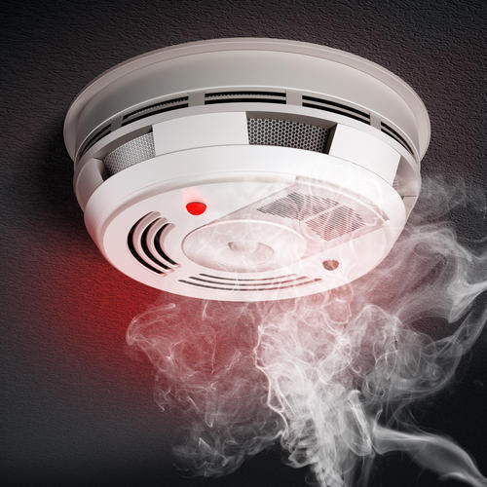

The alarm may activate sprinklers or other suppression systems to control the fire.

* Automatic Fire Extinguishing Systems (AFES): These systems, such as water-based sprinklers or chemical suppression systems, automatically activate upon detecting fire, controlling or extinguishing it without human intervention.

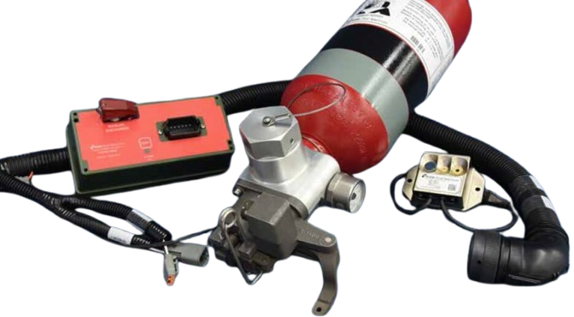

* Automatic Open Exit Door Systems: These systems are designed to open exit doors automatically when a fire or emergency situation is detected, ensuring that people can evacuate quickly and safely.

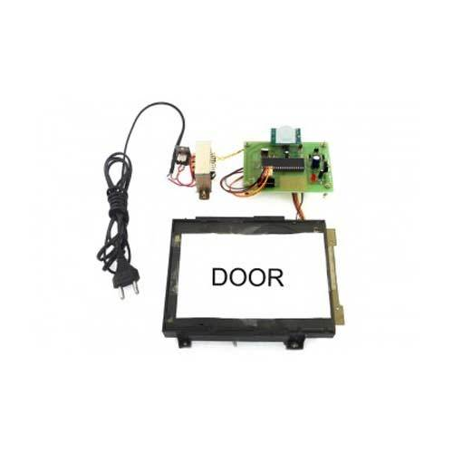

* Smoke Control and Ventilation Systems: Designed to control and manage smoke spread, these systems activate fans or other ventilation mechanisms to direct smoke to specific areas, preventing it from obstructing exit routes.
* Intelligent Building Management Systems (BMS): In smart buildings, BMS systems can automatically control fire suppression, lighting, ventilation, and door control systems during emergencies. These systems can use sensors and algorithms to manage evacuation routes and responses effectively.

## **2.2 Critique of Existing Design**

Despite their effectiveness, existing systems have several limitations:

* **Lack of Integration**: Many systems are standalone and do not communicate with each other, leading to disjointed responses in emergencies. For instance, automatic fire alarms might not automatically trigger the opening of exit doors, creating bottlenecks in evacuation.
* **Dependence on Manual Overrides**: Some systems require manual intervention to function properly or be activated in case of a failure, reducing their reliability.
* **False Alarms**: In many existing systems, fire alarms or automatic extinguishing systems can be triggered by false positives, such as smoke from cooking or dust, which may cause unnecessary disruptions and stress.
* **Limited Adaptability**: Existing systems often fail to adjust to specific building layouts or conditions. For example, traditional fire alarm systems may not efficiently account for changing building layouts or newly added rooms.
* **Inefficient Evacuation Pathways**: Some systems do not prioritize evacuation paths or real-time adjustments based on the situation, which can result in congested exit routes during evacuations.

## **2.3 Evaluation of proposal design**

### 2.3.1 Power supply

The power supply consists of a step-down transformer, rectifier circuit and smoothening capacitors as well as voltage regulator IC.

1. **Transformer**

A transformer is a static device that transfers electrical energy from one circuit to another through inductively coupled conductors—the transformer's coils. A varying current in the first or primary winding creates a varying magnetic flux in the transformer's core and thus a varying magnetic field through the secondary winding. This varying magnetic field induces a varying electromotive force (EMF) or "voltage" in the secondary winding. This effect is called mutual induction.

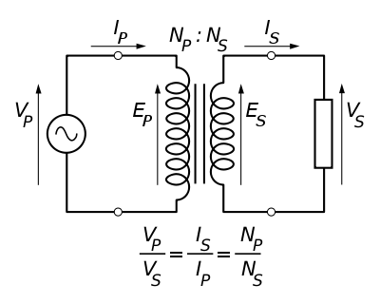

1. **Rectification**

This is the process of converting AC to DC. This is required because the electronic circuits operate with DC while the main supply is AC.

**Full rectification**

A full-wave rectifier converts the whole of the input waveform to one of constant polarity (positive or negative) at its output. Full-wave rectification converts both polarities of the input waveform to DC (direct current), and is more efficient. However, in a circuit with a non-center tapped transformer, four diodes are required instead of the one needed for half-wave rectification. Four diodes arranged this way are called a diode bridge or bridge rectifier.

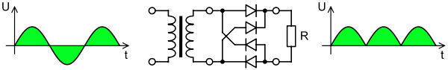

For single-phase AC, if the transformer is center-tapped, then two diodes back-to-back (i.e. anodes-to-anode or cathode-to-cathode) can form a full-wave rectifier. Twice as many windings are required on the transformer secondary to obtain the same output voltage compared to the bridge rectifier above.

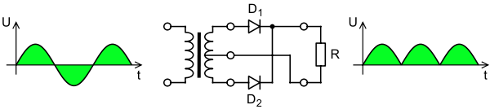

1. **Smoothing**

To smooth the output of the rectifier a reservoir capacitor is used - placed across the output of the rectifier and in parallel with the load. This capacitor charges up when the voltage from the rectifier rises above that of the capacitor and then as the rectifier voltage falls, the capacitor provides the required current from its stored charge.

Smoothing is performed by a large value electrolytic capacitor connected across the DC supply to act as a reservoir, supplying current to the output when the varying DC voltage from the rectifier is falling. The diagram shows the unsmoothed varying DC (dotted line) and the smoothed DC (solid line). The capacitor charges quickly near the peak of the varying DC, and then discharges as it supplies current to the output.

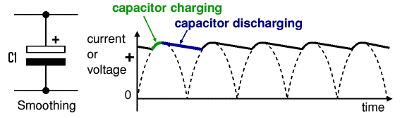

The value of the capacitor used can be got using the formula shown below.

|  |  |
| --- | --- |
| Smoothing capacitor for 10% ripple, C = | 5 × Io |
| Vs × f |

C = smoothing capacitance in farads (F)  
Io = output current from the supply in amps (A)  
Vs = supply voltage in volts (V), this is the peak value of the unsmoothed DC  
f    = frequency of the AC supply in hertz (Hz).

**4)Voltage regulation**

A voltage regulator is designed to automatically adjust the amount of current flowing through the load to maintain a constant output voltage by comparing the supply’s DC output with a fixed or programmed internal reference voltage. A simple regulator consists of a sampling circuit, an error amplifier, a conduction element, and a voltage reference element.

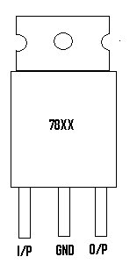

The digit XX represents the output voltage. E.g. 7812 is a 12-volt output regulator. This device can handle up to 1.5 A in properly heat sunk. To remove unwanted input or output spikes/noise, capacitors can be attached to the regulator ‘s input and output terminals.

The standard 7800 series regulators

|  |  |
| --- | --- |
| Type number | output |
| 7805 | +5v |
| 7806 | +6v |
| 7808 | +8v |
| 7809 | +9v |
| 7812 | +12v |
| 7815 | +15v |
| 7818 | +18v |
| 7824 | +24v |

### 2.3.2 smoke sensor

A smoke detector is a device that senses smoke, typically as an indicator of fire. There are two main types.

1. **Optical smoke sensor**

An optical detector is a light sensor. The components of the light sensor are the light source (incandescent bulb or Light-emitting diode), a lens, and a photoelectric receiver (typically a photodiode). In spot-type detectors, all of these components are arranged inside a smoke chamber where smoke from a nearby fire will flow. In large open areas such as atria and auditoriums, optical beam smoke detectors are used. A wall-mounted unit emits a beam of infrared or ultraviolet light which is either received and processed by a separate device or reflected back to the transmitter/receiver by a reflector.

1. **Air sampling smoke sensor**

An air-sampling smoke detector is capable of detecting microscopic particles of smoke. Most air-sampling detectors are aspirating smoke detectors, which work by actively drawing air through a network of small-bore pipes laid out above or below a ceiling in parallel runs covering a protected area. Small holes drilled into each pipe form a matrix of holes (sampling points), providing an even distribution across the pipe network. Air samples are drawn past a sensitive optical device, often a solid-state laser, tuned to detect the extremely small particles of combustion. Air-sampling detectors may be used to trigger an automatic fire response, such as a gaseous fire suppression system, in high-value or mission-critical areas, such as archives or computer server rooms.

### 2.3.3 Heat sensor

1. **LM35**

LM35 is a type of commonly used temperature sensor, that can be used to measure temperature with an electrical output compared to the temperature in (°C). It can measure temperature in a better way than a thermistor.

LM35 is used in industries and commercial buildings where high accuracy of temperature measuring is needed. I will give you a detailed overview of this temperature sensor in today’s post where we will have a look at its pinout, working, protocol, etc. I will also share some links to projects where I have interfaced with Arduino or other microcontrollers. If you have any questions please ask in the comments, I will resolve your queries and will comprehensively guide you. So, let’s get started with the basic Introduction to LM35:

* LM35 has three pinouts which are:
  + **PIN 1:** Vcc, it used as input at this pin we apply +5 V input voltage.
  + **PIN 2:**At this pin, we get output voltage.
  + **PIN 3:**This pin is used for ground.
* Here’s the table for LM35 Pinout for better understanding:

|  |  |  |
| --- | --- | --- |
| No. | Parameter | Pin Type |
| 1. | Vcc | Power Pin (Connected to +5V) |
| 2 | Vout | Output Pin (It should be connected with an analog pin of Microcontroller) |
| 3 | Ground | Ground Pin (Connected to 0V or GND ) |

For a better understanding lets, have a look at LM35 Pinout figure.

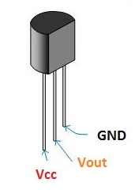

### 2.3.4 Audio alarm

A buzzer or beeper is an audio signaling device, which may be mechanical, electromechanical, or Piezoelectric. A piezoelectric element may be driven by an oscillating electronic circuit or other audio signal source, driven with a piezoelectric audio amplifier. Sounds commonly used to indicate that a button has been pressed are a click, a ring or a beep. Below is the piezo buzzer internal structure.

|  |
| --- |
|  |
|  |

### 2.3.5 Control unit

A microcontroller (μC or uC) is a solitary chip microcomputer fabricated from VLSI fabrication. A micro controller is also known as embedded controller. Today various types of microcontrollers are available in market with different word lengths such as 4bit, 8bit, 64bit and 128bit microcontrollers. Microcontroller is a compressed microcomputer manufactured to control the functions of embedded systems in office machines, robots, home appliances, motor vehicles, and a number of other gadgets. A microcontroller is comprising components like – memory, peripherals and most importantly a processor. Microcontrollers are basically employed in devices that need a degree of control to be applied by the user of the device.

#### Microcontroller Basics:

Any electric appliance that stores, measures, displays information or calculates comprise of a microcontroller chip inside it. The basic structure of a microcontroller comprise of:-

1. CPU – The microcontrollers brain is named as CPU. CPU is the device which is employed to fetch data, decode it and at the end complete the assigned task successfully. With the help of CPU all the components of microcontroller is connected into a single system. Instruction fetched by the programmable memory is decoded by the CPU.
2. Memory – In a microcontroller memory chip works same as microprocessor. Memory chip stores all programs & data. Microcontrollers are built with certain amount of ROM or RAM (EPROM, EEPROM, etc) or flash memory for the storage of program source codes.
3. Input/output ports – I/O ports are basically employed to interface or drive different appliances such as- printers, LCD’s, LED’s, etc.
4. Serial Ports – These ports give serial interfaces amid microcontroller & various other peripherals such as parallel port.
5. Timers – A microcontroller may be in-built with one or more timer or counters. The timers & counters control all counting & timing operations within a microcontroller. Timers are employed to count external pulses. The main operations performed by timers’ are- pulse generations, clock functions, frequency measuring, modulations, making oscillations, etc.
6. ADC (Analog to digital converter) – ADC is employed to convert analog signals to digital ones. The input signals need to be analog for ADC. The digital signal production can be employed for different digital applications (such as- measurement gadgets).
7. DAC (digital to analog converter) – this converter executes opposite functions that ADC perform. This device is generally employed to supervise analog appliances like- DC motors, etc.
8. Interpret Control- This controller is employed for giving delayed control for a working program. The interpret can be internal or external.
9. Special Functioning Block – Some special microcontrollers manufactured for special appliances like- space systems, robots, etc, comprise of this special function block. This special block has additional ports so as to carry out some special operations.

**Types of Microcontrollers**

**Microcontroller 8051**

It is a 40pin microcontroller with Vcc of 5V connected to pin 40 and Vss at pin 20 which is kept 0V. And there are input and output ports from P1.0 – P1.7 and which having open drain feature. Port3 has got extra features. Pin36 has open drain condition and pin17 has internally pulled up transistor inside the microcontroller. When we apply logic 1 at port1 then we get logic 1 at port21 and vice versa. The programming of microcontroller is dead complicate. Basically we write a program in C-language which is next converted to machine language understand by the microcontroller. A RESET pin is connected to pin9, connected with a capacitor. When the switch is ON, the capacitor starts charging and RST is high. Applying a high to the reset pin resets the microcontroller. If we apply logic zero to this pin, the program starts execution from the beginning.

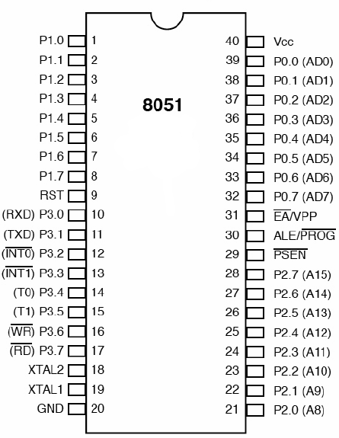

**AVR ATMEGA 328**

The ATmega328 and ATmega8 are pin-compatible ICs but functionally they are different. The ATmega328 has a flash memory of 32kB, whereas the ATmega8 has 8kB. Other differences are extra SRAM and EEPROM, the addition of pin change interrupts and timers. Some of the features of ATmega328 are:

Features of ATmega328:

* 28-pin AVR microcontroller
* Flash program memory of 32kbytes
* EEPROM data memory of 1kbytes
* SRAM data memory of 2kbytes
* I/O pins are 23
* Two 8-bit timers
* A/D converter
* Six channel PWM
* In built USART
* External Oscillator: up to 20MHz

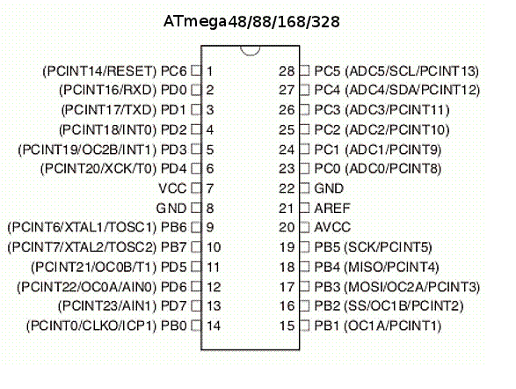

**PIC16F877**

PIC is a peripheral interface controller, developed by general instrument’s microelectronics, in the year of 1993. It is controlled by the software. They could be programmed to complete many task and control a generation line and many more. PIC microcontrollers are finding their way into new applications like smart phones, audio accessories, video gaming peripherals and advanced medical devices.

**Core Features:**

* High-performance RISC CPU
* Up to 8K x 14 words of FLASH program memory
* 35 Instructions (fixed length encoding-14-bit)
* 368×8 static RAM based data memory
* Up to 256 x 8 bytes of EEPROM data memory
* Interrupt capability (up to 14 sources)
* Three addressing modes (direct, indirect, relative)
* Power-on reset (POR)
* Harvard architecture memory
* Power saving SLEEP mode
* Wide operating voltage range: 2.0V to 5.5V
* High sink / source current: 25mA
* Accumulator based machine

**Peripheral Features:**

* 3 Timer/counters (programmable pre-scalars)

–        Timer0, Timer2 are 8-bit timer/counter with 8-bit pre-scalar

–        Timer1 is 16-bit, can be incremented during sleep via external crystal/clock

* Two capture, compare, PWM modules

–        Input capture function records the Timer1 count on a pin transition

–        A PWM function output is a square wave with a programmable period and duty cycle.

* 10-bit 8 channel analog-to-digital converter
* USART with 9-bit address detection
* Synchronous serial port with master mode and I2C Master/Slave
* 8-bit parallel slave port

**Analog Features:**

* 10-bit, up to 8-channel Analog-to-Digital Converter (A/D)
* Brown-out Reset (BOR)
* Analog Comparator module (Programmable input multiplexing from device inputs and

### 2.3.6 GSM module

A **GSM modem** is a specialized type of modem that accepts a SIM card, and operates over a subscription to a mobile operator, just like a mobile phone. From the mobile operator's perspective, a GSM modem looks just like a mobile phone.

SIM800L GSM/GPRS module

At the heart of the module is a SIM800L GSM cellular chip from SimCom. The operating voltage of the chip is from **3.4V to 4.4V**, which makes it an ideal candidate for direct LiPo battery supply. This makes it a good choice for embedding into projects without a lot of space.

All the necessary data pins of the SIM800L GSM chip are broken out into 0.1″ pitch headers. This includes pins required for communication with a microcontroller over **UART**. The module supports baud rates from **1200bps** to **115200bps** with Auto-Baud detection.

The module needs an external antenna to connect to a network. The module usually comes with a **Helical Antenna** and solders directly to the NET pin on the PCB. The board also has a U.FL connector facility in case you want to keep the antenna away from the board.

There’s a SIM socket on the back! Any activated, **2G micro SIM card** would work perfectly. Correct direction for inserting SIM card is normally engraved on the surface of the SIM socket.

This module measures only 1 inch² but packs a surprising amount of features into its little frame. Some of them are listed below:

* Supports Quad-band: GSM850, EGSM900, DCS1800 and PCS1900
* Connect onto any global GSM network with any 2G SIM
* Make and receive voice calls using an external 8Ω speaker & electret microphone
* Send and receive SMS messages
* Send and receive GPRS data (TCP/IP, HTTP, etc.)
* Scan and receive FM radio broadcasts
* Transmit Power:
  + Class 4 (2W) for GSM850
  + Class 1 (1W) for DCS1800
* Serial-based AT Command Set
* FL connectors for cell antennae
* Accepts Micro SIM Card

For more information about SIM800L GSM Cellular chip, check out this datasheet.

### 2.3.7Motor

**Servo motor**

A servo motor is an electrical device that can push or rotate an object with great precision. It is just made up of a simple motor that runs through a servo mechanism. If the motor used is DC powered then it is called a DC servo motor, and if it is AC powered motor then it is called an AC servo motor. There is a very high torque servo motor in a small and lightweight package.

A servo consists of a Motor (DC or AC), a potentiometer, a gear assembly, and a controlling circuit. First of all, we use gear assembly to reduce RPM and increase the torque of the motor.

All motors have three wires coming out of them. Out of which two will be used for Supply (positive and negative) and one will be used for the signal that is to be sent from the MCU.

The Servo motor is controlled by PWM (Pulse with Modulation) which is provided by the control wires. There is a minimum pulse, a maximum pulse, and a repetition rate. The Servo motor can turn 90 degrees from either direction from its neutral position. The servo motor expects to see a pulse every 20 milliseconds (ms) and the length of the pulse will determine how far the motor turns. For example, a 1.5ms pulse will make the motor turn to the 90° position, such as if the pulse is shorter than 1.5ms shaft moves to 0° and if it is longer than 1.5ms then it will turn the servo to 180°.

 The Servo motor works on the PWM (Pulse width modulation) principle, which means its angle of rotation is controlled by the duration of the applied pulse to its Control PIN. The Servo motor is made up of a DC motor which is controlled by a variable resistor (potentiometer) and some gears. High-speed force of the DC motor is converted into torque by Gears.

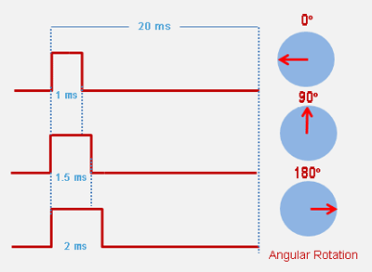

Servo motor can be rotated from 0 to 180 degree, but it can go up to 210 degree, depending on the manufacturing. This degree of rotation can be controlled by applying the Electrical Pulse of proper width, to its Control pin. Servo checks the pulse in every 20 milliseconds. Pulse of 1 ms (1 millisecond) width can rotate servo to 0 degree, 1.5ms can rotate to 90 degree (neutral position) and 2 ms pulse can rotate it to 180 degree.

All servo motors work directly with your +5V supply rails but we have to be careful on the amount of current the motor would consume, if you are planning to use more than two servo motors a proper servo shield should be designed.

## **2.4 Summary of the gaps identified**

The gaps identified in existing systems that motivate the need for the proposed design include:

* Lack of System Integration: Existing systems do not always work in tandem, leading to inefficiencies and delays during emergencies. The proposed design addresses this by integrating detection, suppression, and evacuation functions into one system.
* Limited Adaptability: Traditional systems do not adapt to varying building layouts or emergencies. The proposed design uses intelligent sensors and algorithms to dynamically adjust to specific conditions, optimizing evacuation routes and suppression measures.
* Reliability Issues: Many systems depend on manual overrides and have a higher risk of false alarms. The new design’s self-monitoring and automated response features reduce human intervention, improving reliability and minimizing false positives.
* Slow Response Times: Existing systems might not immediately trigger all required actions (e.g., opening exit doors). The proposed design ensures swift, coordinated responses to maximize occupant safety and evacuation efficiency.

# CHAPTER THREE: PROJECT DESIGN

## **3.1 Power supply**

The power supply consists of a step-down transformer, rectifier circuit, and smoothening capacitors as well as a voltage regulator IC.

### 3.1.1Transformer



The transformer in this project aims to step down the voltage from 240 volts AC to 12 volts AC. Therefore, the step-down laminated core transformer is the one used because it is designed to work at a low frequency. Since the electronic circuit consumes a maximum of 400mA, the current rating of the transformer should be slightly higher than the required output to increase the life of the transformer. Therefore, the transformer selected for this work is 240 volts to 12 volts, 500mA laminated core transformer.

To get the input current, the transformer equation can be used.

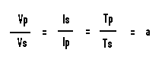

From here we can get

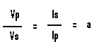

Vp=240V

Vs= 12V

Is= 0.5A

Therefore,

240 / 12 = 0.5 / Ip = 20

Ip which is the input current to the transformer can be calculated as follows.

Ip = 0.5 / 20

Ip = 0.025 A

The power rating of the transformer can be calculated as follows.

240V * 0.025A = 6 VA

### 3.1.2 Rectification

A full wave four-diode bridge rectifier is used here. This is because it yields the best results at the most economical level.



This is because it yields the best results at the most economical level. Since we are rectifying ac power, rectifier diode is used here. Each diode is supposed to handle the transformer maximum output current and voltage. Therefore, the diode current is 400mA and a peak inverse voltage of 12 volts.

The diode selected for this is therefore 1N4007. This can handle a current of 1000mA and peak inverse voltage of 1000 volts.

### 3.1.3 Smoothing



|  |  |
| --- | --- |
| Smoothing capacitor for 10% ripple, C = | 5 × Io |
| Vs × f |

C = smoothing capacitance in farads (F)  
Io = output current from the supply in amps (A)  
Vs = supply voltage in volts (V), this is the peak value of the unsmoothed DC  
f    = frequency of the AC supply in hertz (Hz).

Io= 400mA= 0.4A

Vs= 12 V

F= 50

Therefore,

C = (5 * 0.4) / (12 * 50)

C = 0.0033F

C = 3333 uF

### 3.1.4 Voltage regulator

The 78XX positive voltage regulator IC is used. This is because our voltage is a positive one and it can handle up to 1 A output therefore appropriate for our load which is 900mA. Since our required output is 5 volts, we use 7805 voltage regulator ICs.



### 3.1.5 Voltage comparator

LM 324 is the IC selected for the comparator. It is stable in its operation and locally available.



The comparator is used in conjunction with reference voltage circuit.

**Reference circuit**

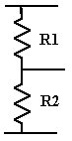

The reference circuit is comprised of a voltage divider formed by a resistor network

(R1 and R2). The purpose of this is to set a voltage that will be used to determine high levels of gas detected. This voltage is supplied to the inverting terminal of the comparator. Substantial level of gas produces 2.5 volts DC as the sensor output.

We limit the current through R1 & R2 to 0.6mA. Considering that the supply voltage is 5 volts, **R1+R2** can be calculated as follows,



Since we need a reference voltage of 2.5 volts, each of the resistors must drop 2.5 volts. Therefore each of the resistors R1 & R2= 8.3 / 2=4.15 KΩ

## 3.2 **Smoke sensing circuit**

This is comprised of a smoke sensor and voltage comparator.

**Smoke sensor**

I4 Series Combination CO/Photoelectric Smoke Detector is used. This is due to its stability.



## 3.3 **Flame sensor**



## 3.4 **Alarm driver**

Since the buzzer is rated 12 volts, and has a current of 50mA, the switching device should be rated at least higher than 12 volts and 50mA. Therefore, BC 337 n-p-n transistor is used here. This is rated 40 volts Vceo and has a collector current of 500mA. It is described below.



The base current of BC337 should not exceed 1.2 mA. The output of the flip flop is a maximum of 5 volts. To offer this protection, R7 is used. Therefore,



**R= 4 KΩ**

## 3.5 **Audio alarm**

Self oscillating piezo buzzer is selected since it is small in size and therefore minimizes space therefore reduces bulkiness.



## 3.6 **Control circuit**

AT Mega 328P microcontroller is used here due to its high number of pins and also its stability.



Resistor R is used to set pin 4 high for. Since the input impedance is very high, the current through the resistor R can be limited to 1mA. Its value can therefore be calculated as follows.

**R=V/I**

**R= 5 volts/0.001A**

**R=5KΩ**

## 3.7 **GSM module**

GSM 800 module is selected due to its ease of use.



## 3.8 **Switching circuit**

In our case a transistor switch is considered. This is because it is easier to switch with compared to other switching devices. Since the load operated is rated 240 volts ac, relay is used alongside the transistor. The circuit is illustrated below.



A 12-volt relay with normally open contacts is used. The relay coil has an impedance of 200 ohms. Therefore, when switched to 12 volts,

**Q1 collector current (Ic) = 12/200= 0.06A=60mA**.

Therefore, Q1 should withstand a collector current of 60 mA and Vceo of 12 volts.

Therefore, the most ideal transistor for this is BC 337. BC337 can handle a collector current of 500mA and Vceo of 40 volts.

The base current of BC337 should not exceed 1.2 mA. The output of the microcontroller is a maximum of 5 volts. To offer this protection, R7 is used. Therefore,

**R7 = 5 / 0.0012=4167 Ω**

Two such similar circuits are used here.

## 3.9 **DOOR MOTOR**

A 5V Servo motor is used to facilitate bidirectional control.



The maximum output current of the relay contacts is 10A. The maximum output power can therefore be calculated.

**Power (P) = current (I) * voltage (V)**

**Power (P) = 10 * 12**

**Power (P) = 120 watts**

The motor used should therefore not exceed 120W

## 3.12 **CIRCUIT DIAGRAM**



## 3.13 **CIRCUIT OPERATION**

When the switch is closed, the transformer steps down 240V ac to 12 V ac. This is then rectified by the four diode bridge rectifier after which it is smoothened by the 4,200 uF capacitor. The 7805 IC is a voltage stabilizer IC. This is meant to ensure that the circuit is constantly supplied with 5 volts regardless of variation in the source voltage this ensures stable operation of the circuit.

When the smoke rises to substantial level, the voltage out of the sensing module exceeds the reference voltage determined by the 3.5K and 4K resistor rising the comparator output voltage to 5 volts.

The temperature sensor converts temperature to an analog voltage signal whose magnitude rises with temperature. This is fed to the microcontroller which through the use of an internal analog to digital converter module converts the analog signal to binary signals. When the temperature rises unusually high or a voltage signal is detected from the smoke sensor comparator or the temperature sensor comparator, the microcontroller outputs 5 volts through pin 20. This through the transistor wired as a switch turns on the buzzer which generates an audio alarm. Pin 17 of the microcontroller also goes high turning on relay 1 which connects the motor to run in one direction for some time opening the escape door. When the fire threat is no more (after temperature is low and no voltage signals from the comparators), pin 18 goes high turning on relay 2 which runs the motor to run in the opposite direction for some time opening the door.

At the same time the microcontroller sends a text message to the number set through the use of the GSM module alerting of the risk perceived.

-